BARROW PRIMARY SCHOOL
e-mail: head@barrow.lancs.sch.uk
www.barrow.lancs.sch.uk

18th January, 2018

Dear Parent

Our second week of the New Year and it has been lovely to see how well the children have settled back into familiar school routines following the holidays. The children continue to work hard and it is a pleasure to see their excellent work ethic. Please remember to check our school website for up to date information about school and events. We wish you all the very best for 2018.

DINNER MONEY PAYMENT
Payment for KS2 (Y3-6) school lunches is due in advance. The cost is £2.20 per day (£11.00 per week) and is paid via the online Parentpay system. Payment for blocks of weeks, a half term or a full term can also be made. Any credits built up because of absence are carried forward. The cost for this half term (08.01.18 – 09.02.18) is £55.00 and for the full term (08.01.18 – 23.03.18) is £110.00.

PARKING
We have had an incident after school where a pupil has been clipped on the elbow by a car wing mirror. The car was setting off after being partially parked on the pavement. The pupil was fine but was just a little shaken, therefore please can parents be careful when parking outside school.
Also can we please request that you do not park on the school driveway to the car park as access is required at all times and also because of how busy the road and pavement are at this time when exiting the driveway. Please see overleaf for a letter from the Authority regarding parking around schools for your information.

HAWTHORN FARM
We have been asked by the family of Hawthorn Farm, opposite school, to politely request that parents and pupils do not feed or leave food for their pony. This is because it can cause illness to the pony and also food left in the field may attract vermin. They understand that this has purely been done with kindness.

DATES FOR YOUR DIARY …more details to follow
Friday, 2nd February - Fobs Valentine Film Night
Thursday, 22nd February - Life Education Bus
Friday, 23rd February - Life Education Bus
Thursday, 1st March - World Book Day
w/c 5th March - Creativity Week
Monday, 12th March - Parents’ Evening
Friday, 23rd March - Fobs Easter Egg Hunt

Many thanks

Mrs Zoe Mabbott
Associate Head Teacher

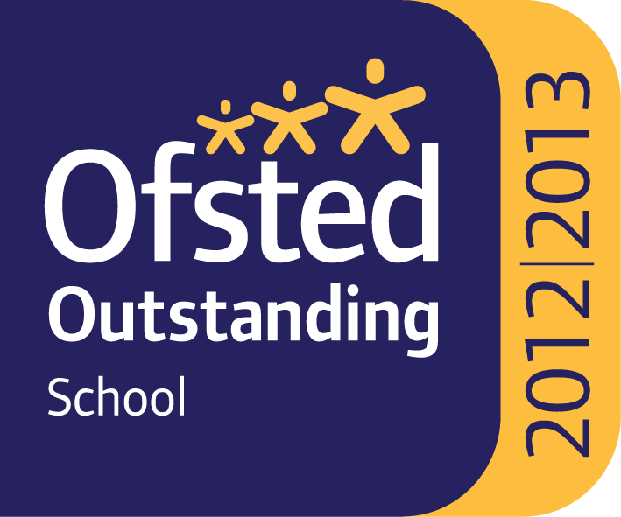

PTO



