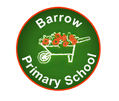
BARROW VC PRIMARY SCHOOL

Old Row, Barrow, Clitheroe, BB7 9AZ
Telephone: 01254 822338
Fax & Answer Machine: 01254 822408
e-mail: head@barrow.lancs.sch.uk

Thursday 18th October 2018

Dear Parents,

‘The Centenary of World War 1’ Open Afternoon

I just wanted to say a huge Thank you to all the parents, grandparents, governors and community visitors who joined us for our first open afternoon. We were amazed as approximately 130 visitors came to look at the work the pupils had produced during our themed week. We also managed to raise £121.15 for the Royal British Legion.
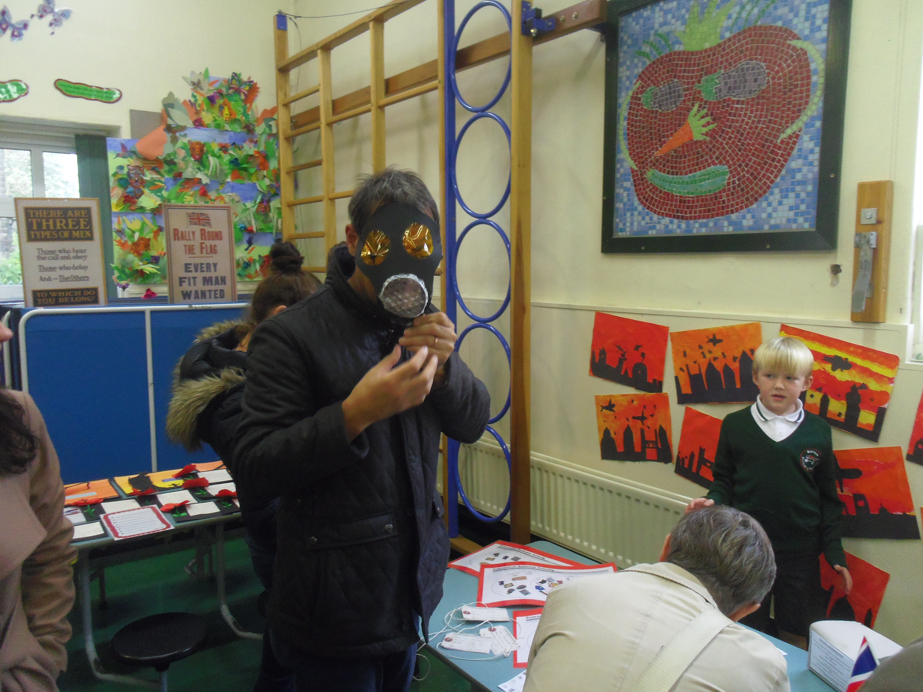
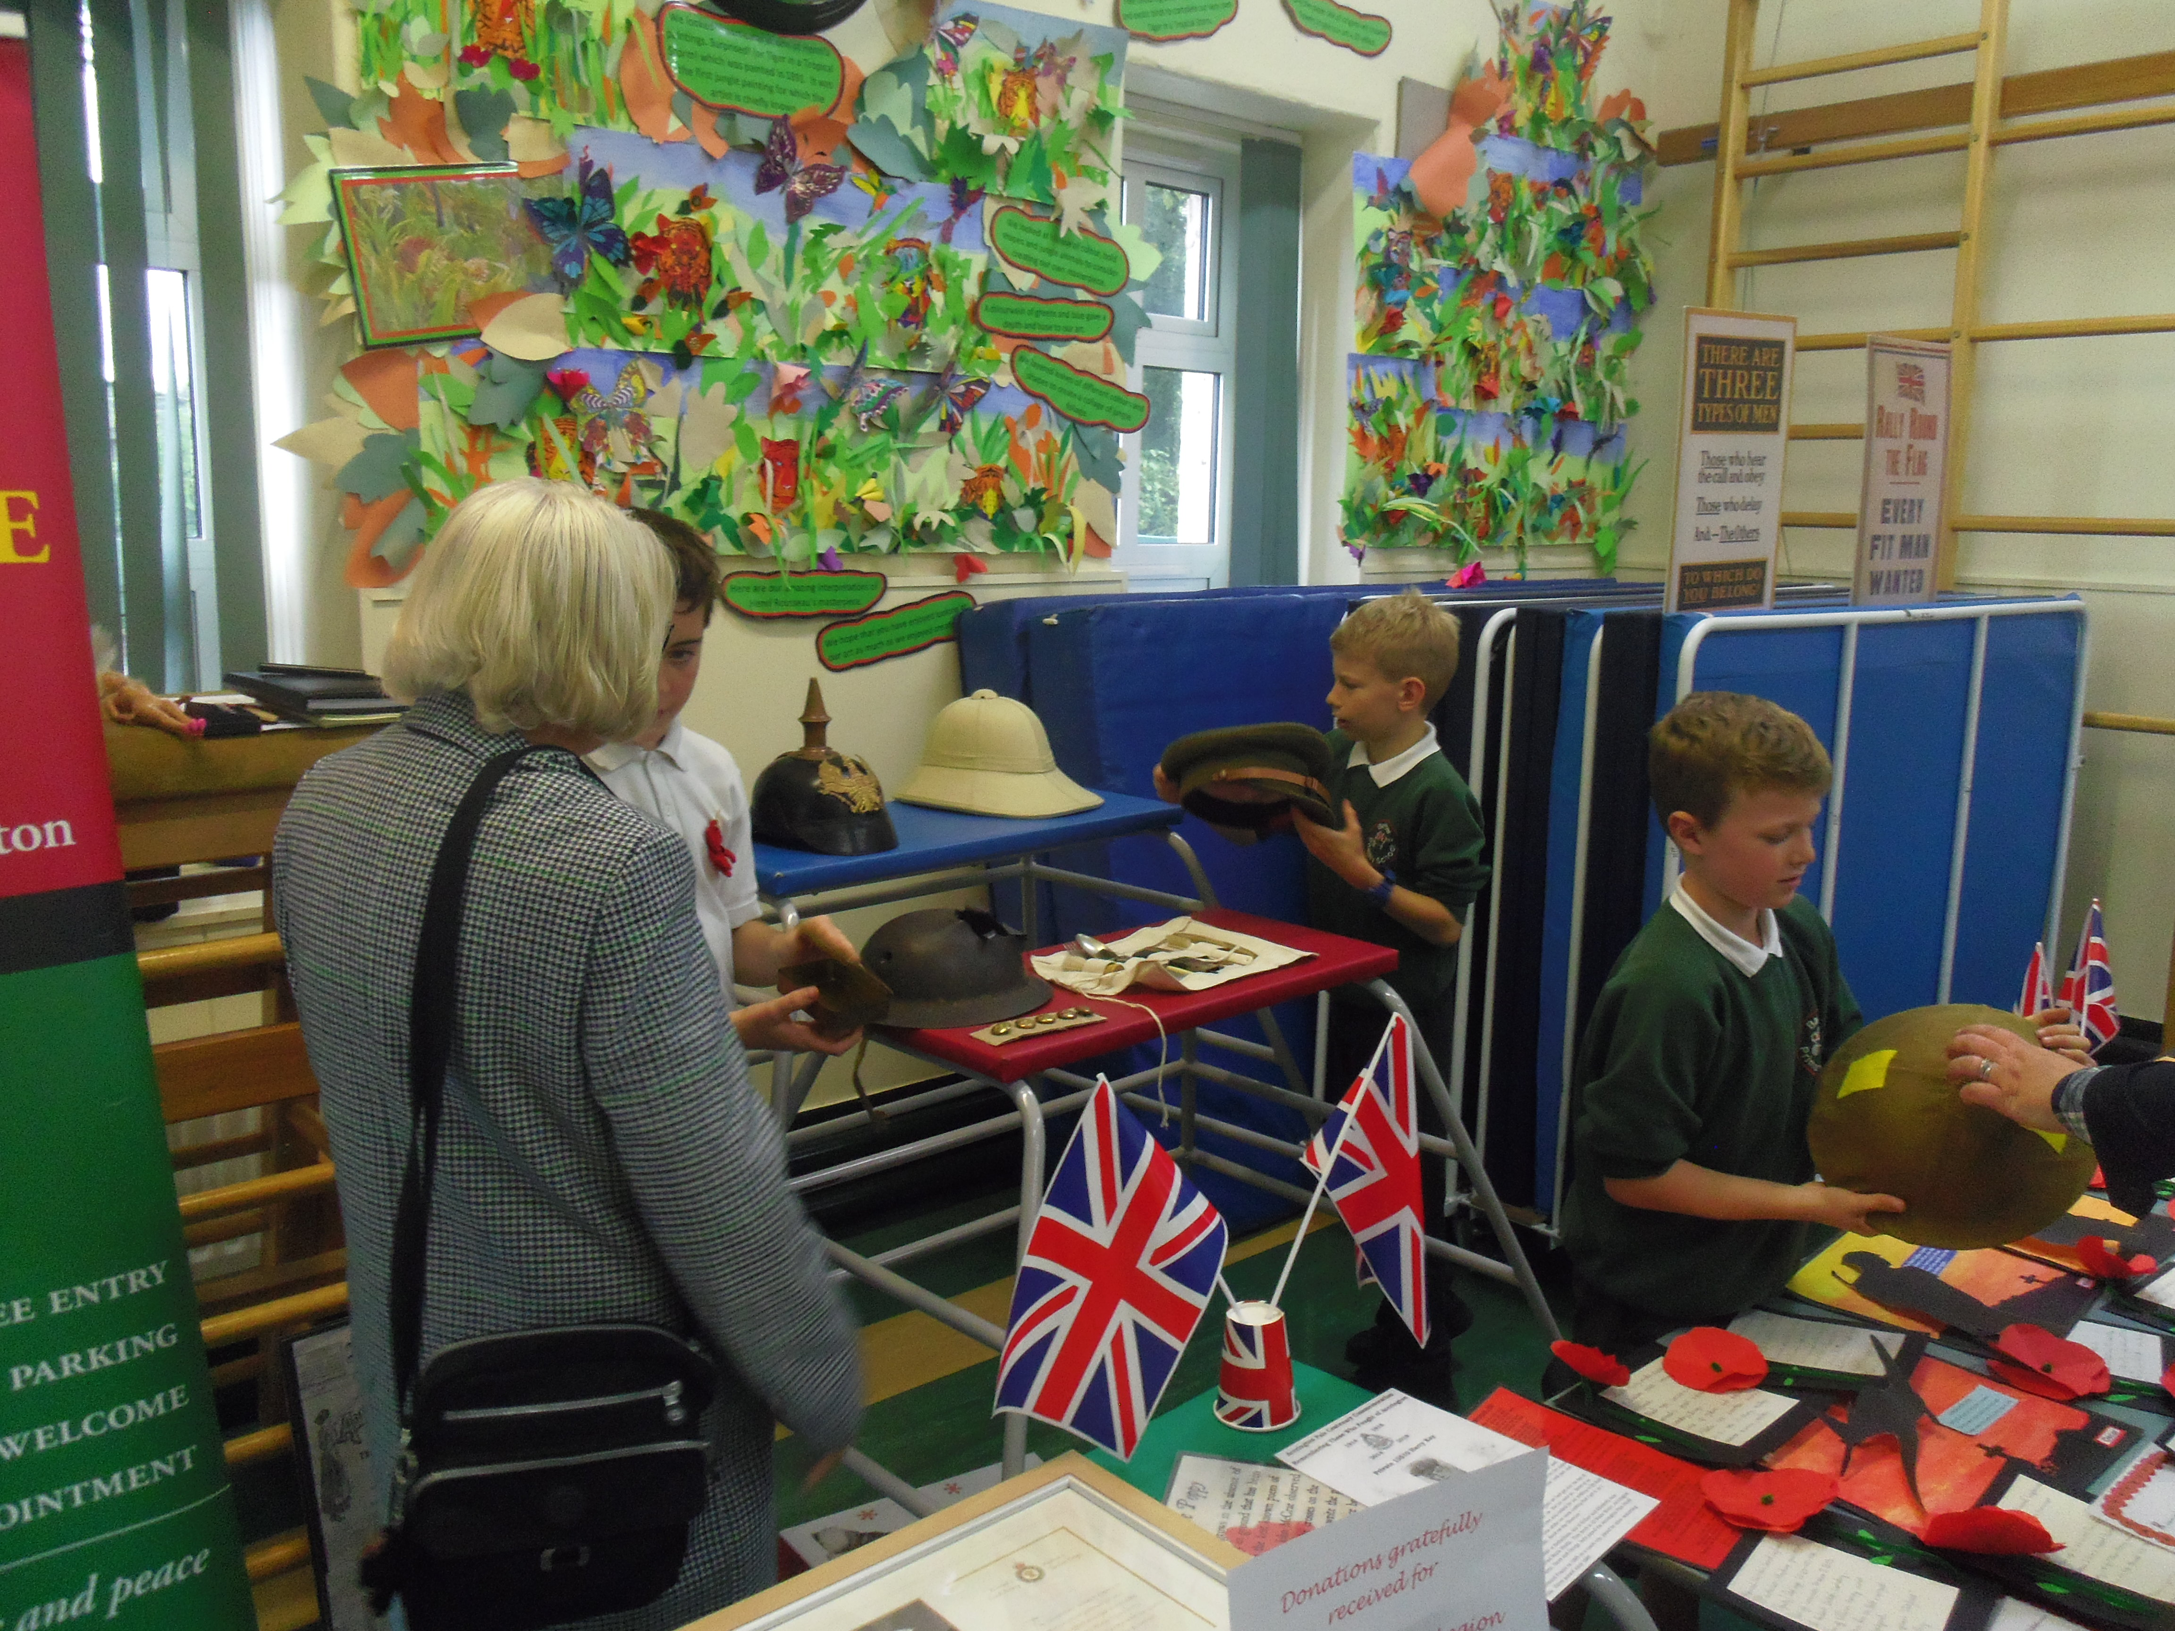
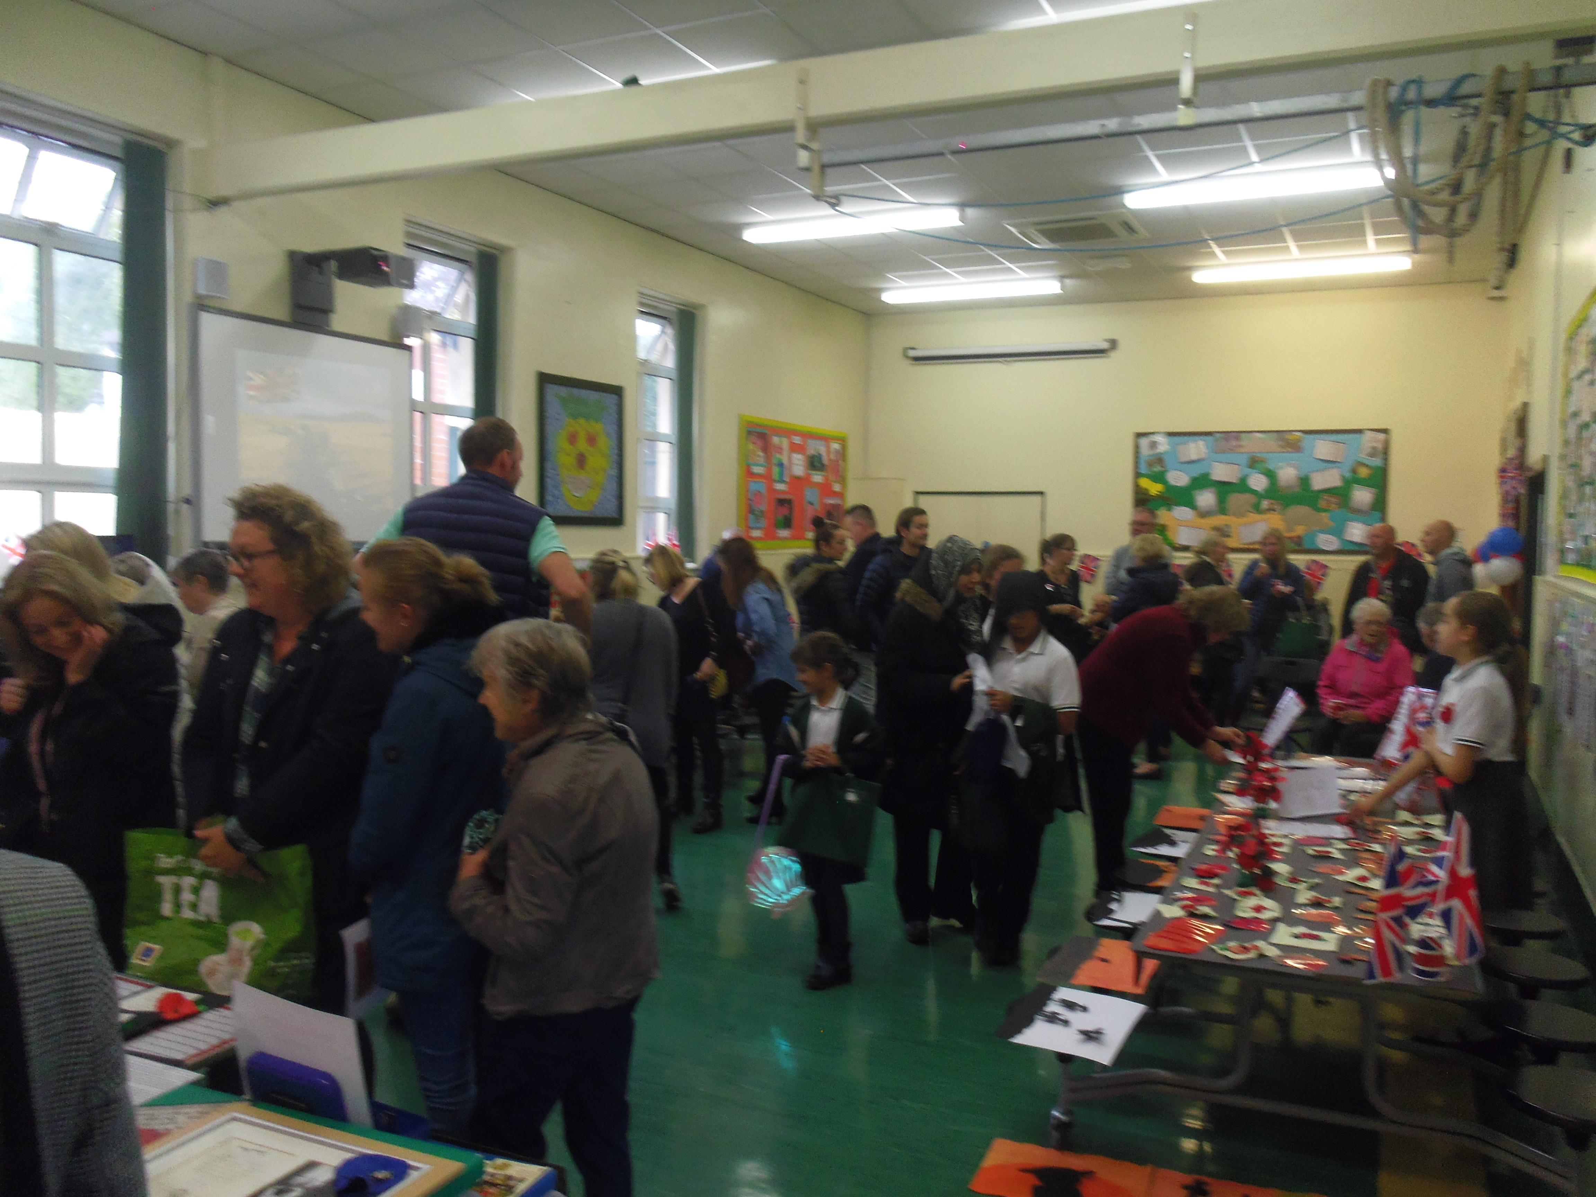
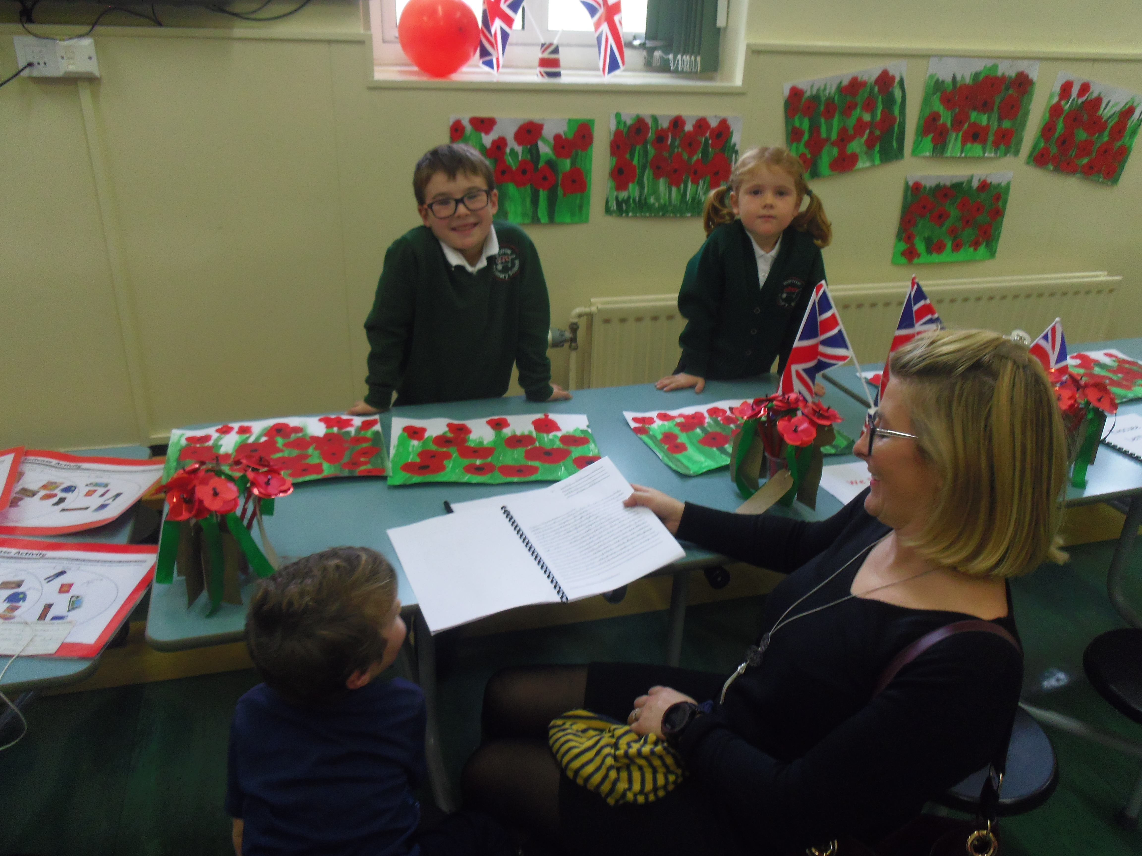

I wanted to share with you some of the lovely feedback we have received.

“Creativity week has been a long standing tradition at Barrow, but we never been able to see the amazing work produced historically and how rewarding for parents, pupils and teachers to display and share their work this way.”

“Let me say Thank you for asking me to attend this afternoon. The children’s work was of such high quality and they really do seem to have taken everything they have been told on board. I’m not ashamed to say that my eyes filled on more than one occasion as I surveyed everything which they had done ... and the ones I spoke to were so knowledgeable and keen to impart that knowledge!”

“Thank you so much for inviting the governors to the Open Afternoon on Friday! I thought the children were superb ambassadors and impressed me (and all the visitors there) with their obvious enthusiasm for the project and the amount they had learned.”

“It was a very professional exhibition that brought the community together and I think the idea to involve the children in the forthcoming Whalley Remembers event is excellent.”

“I really enjoyed working with the children and was impressed by how polite they were. I would also thank the staff as I am sure I must have disrupted their planned lessons.”

“Just wanted to drop you a quick email to say thank you for this afternoon, you, your team and all the children had obviously worked very hard and the children had learned lots, whilst clearly having lots of fun! What a way to remember all those who fought for us all those years ago. It was a lovely as a parent to be part of the school day; the cake was very nice too!!! THANK YOU!”

INSET Day

Please note: school closes for the pupils at 3.30pm on Thursday 18th October. There is a staff training day on Friday 19th October so the school is closed for the pupils.

Family Assembly

Please note: Class 3 assembly date has changed to Friday 9th November. We apologise for any inconvenience caused by this change.

Friday, 9th November Class 3
Friday, 16th November Class 2
Friday, 30th November Class 1

FOBS Disco
The FOBS Fancy Dress Disco is on Friday 2nd November. The cost of £2.50 includes the disco, a drink and a bag of crisps. The Infant disco for pupils in classes 1 and 2 will be from 5.30 – 6.30pm and the junior disco for pupils in classes 3,4 and 5 will be from 6.45pm – 8pm. Tickets can be purchased from the school office.

‘Go Green for the NSPCC’

We will be having a non-uniform day on Thursday 1st November in order to raise funds for the NSPCC ‘Go Green’ campaign. We ask that the pupils all wear something green on the day and make a voluntary contribution of £1 towards this charitable cause. The NSPCC are the UK’s leading children's charity fighting to end child abuse. As an independent charity, which receives around 90% of its funding from supporters, they rely on the support of people like you to make sure we can keep every child who needs us safe. Every pound raised and every penny received will help make sure we can reach more children. During the day the pupils will take part in special ‘Speak out, Stay safe’ assemblies.

We would like to invite the parents to attend a one hour workshop at 3.30pm- 4.30pm on Thursday 1st November as part of this campaign.

Whalley Remembers

Tickets can be purchased from the school office for a Remembrance Community Lunch and Brass Band Concert on Sunday 11th November from 12pm at Whalley Abbey. Adults - £5, Children under 11 - £3.

A huge thank you to the many parents and grandparents who have been knitting poppies for the ‘Whalley Remembers’ events.

Mrs Irshad and the pupils in Class 5 have thoroughly enjoyed the sewing, embroidery and knitting tasks and have, she has decided, to run an after school club incorporating these crafts. Further details to follow. If you have any spare thread, wool or items you feel might be useful please donate them via the school office.



‘A Text to Home’

We are proud of all our pupils for the many different ways they show excellence. Each week the class teachers choose one pupil who has excelled and we send a text home to share this. This week our ‘Text to Home’ pupils are:

Class 1: Jaxson
Class 2: Jacob
Class 3: Amelia M

Class 4: Thomas
Class 5: Millie

Well done. We are proud of you!

Operation Christmas Child (Samaritan’s Purse)

Shoeboxes need to be returned to school by Friday 9th November. If you are able to make more than one shoebox, further leaflets can be collected from the school office.

Message from Miss Rushin for Year 3 pupils re: Mathletics

Pupils in Year 3 will be given their Mathletics logins on the first Friday back after the half term holiday.

A message from the Headteacher

We have had such a rewarding half term. The pupils quickly established routines and the new EYFS pupils settled in well. We opened the Breakfast and Afterschool Club which is now up and running in the modular building. Miss Campbell, Miss Hargreaves and Mrs Miller are a brilliant team who provide excellent care for the pupils. The children in our school have had the opportunity to take part in a range of extra-curricular clubs including Street Dance, Mad Science, French, Netball, Multiskills and Football. Miss Holden has organised sporting activities including District Football trials and Biathlon. She has even organised a fun intervention called ‘Maths on the move’ linking Maths with PE. The Head boy and Head Girl are ambassadors for the school and are even able to give guided tours to prospective parents! The School Council has decided the focus for their fund raising will be to improve playtimes through the purchasing of new playground equipment. Look out for fundraising events in the next half term!

School re-opens on Monday 29th October. I hope that you all have a relaxing and enjoyable half term holiday.

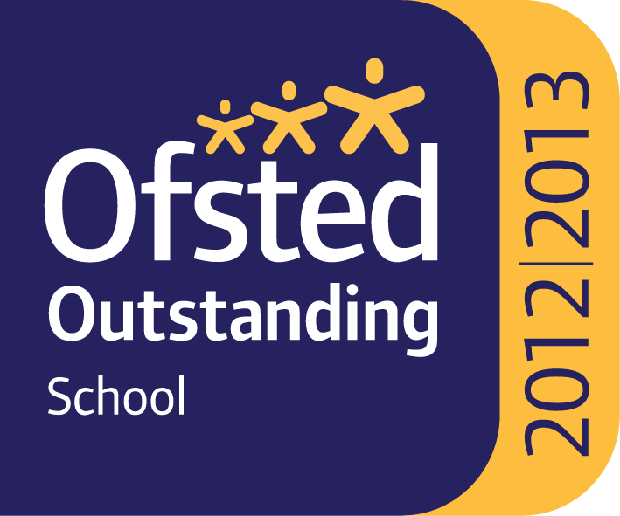

Mrs Welch
Acting Headteacher

